**Task 1**

**Objective: PROGRAMMING**

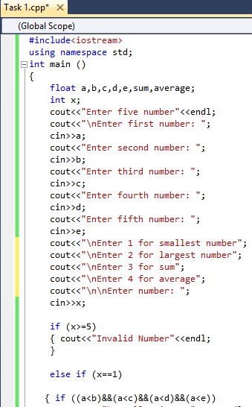Write a C++ Menu driven program that allows a user to enter five numbers and then choose between findings the smallest, largest, sum or average. Use else if statement to determine what action to take.

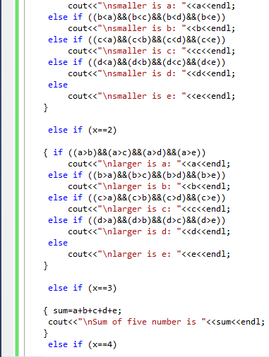

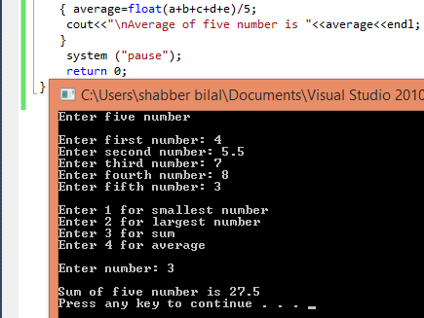

**Task 2**

**Objective: PROGRAMMING**

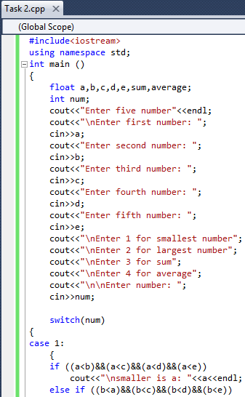Write a C++ Menu driven program that allows a user to enter five numbers and then choose between findings the smallest, largest, sum or average. using switch statement.

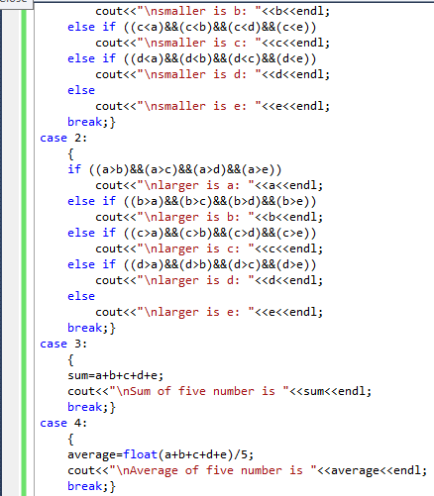

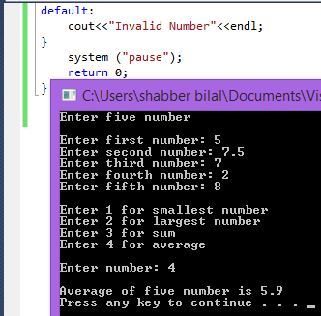

**Task 3**

**Objective:**

Write a program that takes marks as input from 1-100.Find the grade according to following condition and display output as follow

**PROGRAMMING**

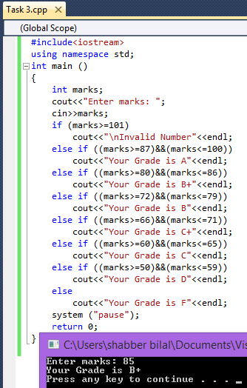**A** marks are above and equal to 87

**B+**marks are between 80 and 86

**B**marks are between 72 and 79

**C+** marks are between 66 and 71

**C** marks are between 60 and 65

**D** marks are between 50 and 59

**F**below 50

**Output**

Enter marks: 85

Your Grade is B+